**Practical 7**

**Title**

Classification using the Weka toolkit – Part 2

**Aim**

To perform classification on data sets using the Weka machine learning toolkit

**Requirements**

1. Load the ‘weather.nominal.arff’ dataset into Weka and run Id3 classification algorithm**.** Answer the following questions

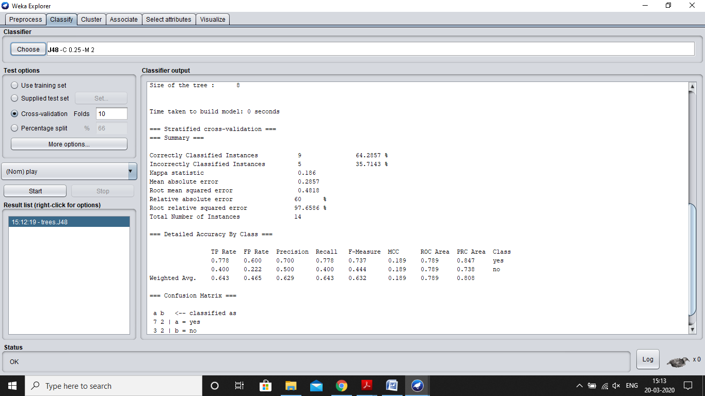

* + List the attributes of the given relation along with the type details
  + Create a table of the weather.nominal.arff data
  + Study the classifier output and answer the following questions
    1. Draw the decision tree generated by the classifier
    2. Compute the entropy values for each of the attributes
    3. What is the relationship between the attribute entropy values and the nodes of the decision tree?
  1. Draw the confusion matrix? What information does the confusion matrix provide?
  2. Describe the Kappa statistic?
  3. Describe the following quantities:
     + TP Rate
     + FP Rate
     + Precision
     + Recall

1. Load the ‘weather.arff’ dataset in Weka and run the Id3 classification algorithm. What problem do you have and what is the solution?

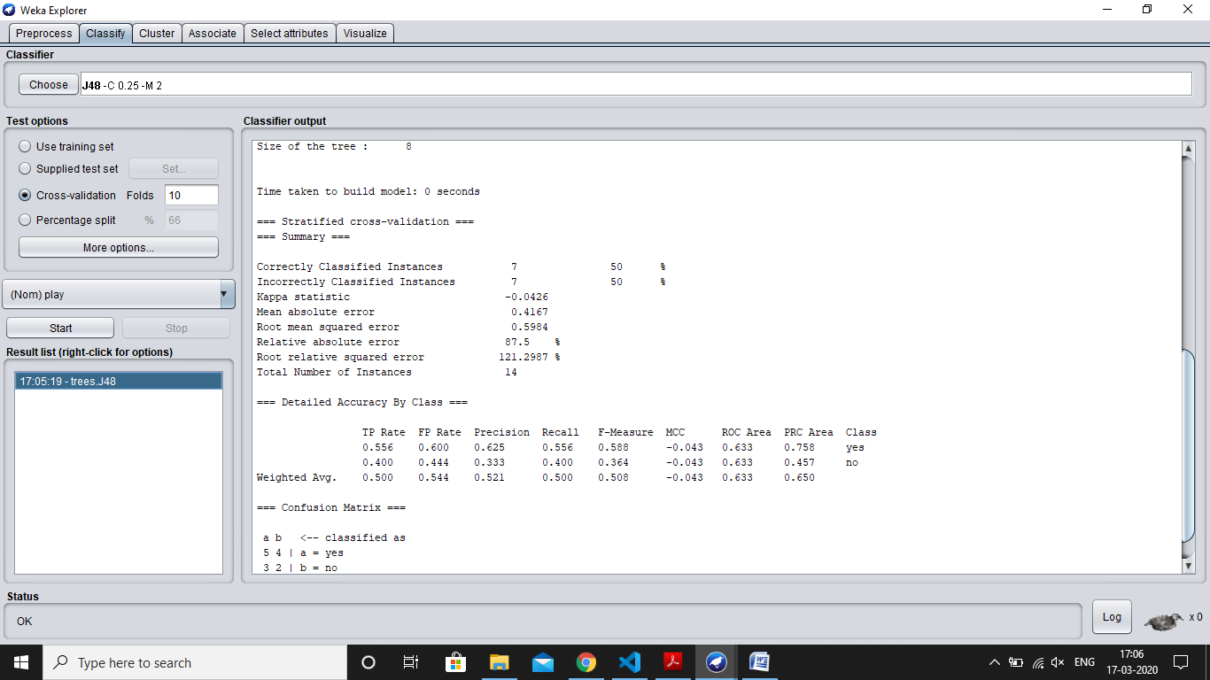

1. Load the ‘weather.arff’ dataset in Weka and run the OneR rule generation algorithm.Write the rules that were generated.

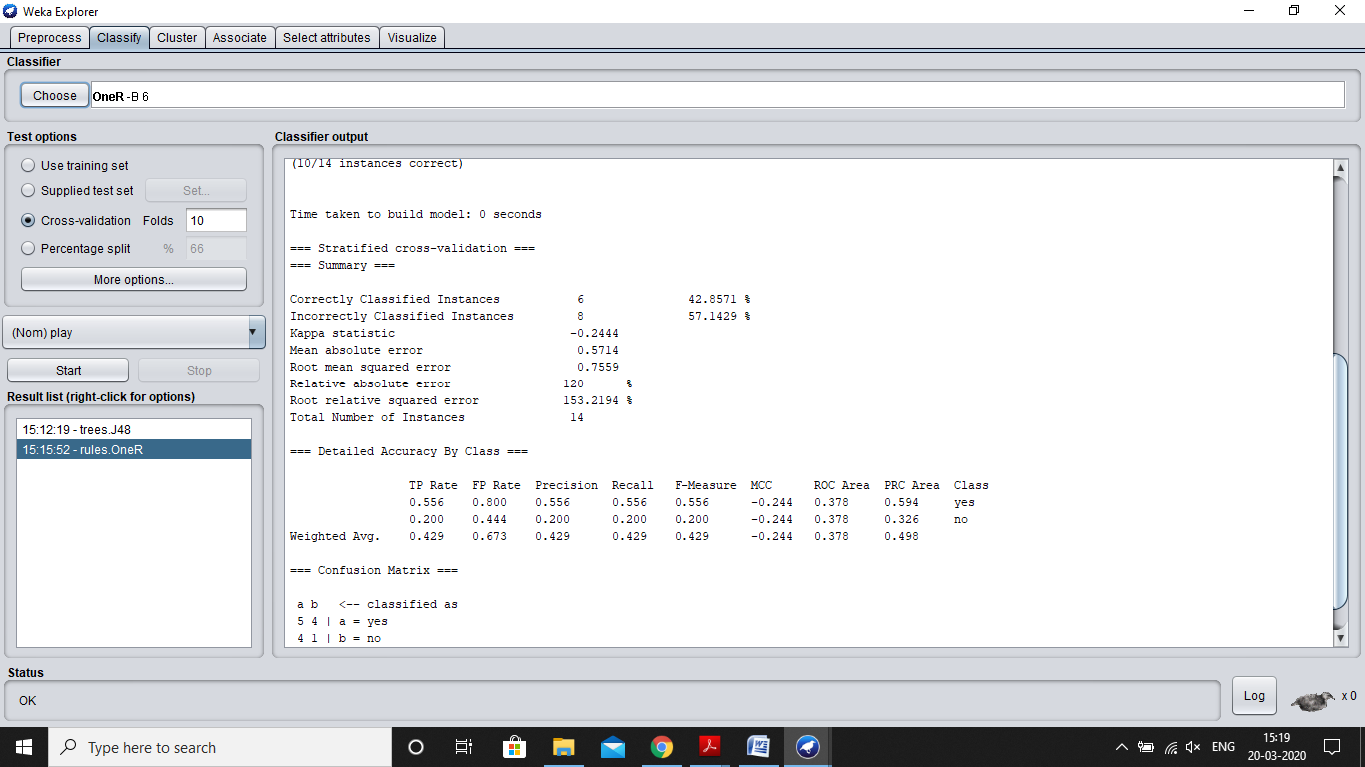

1. Load the glass.arff dataset and perform the following tasks?

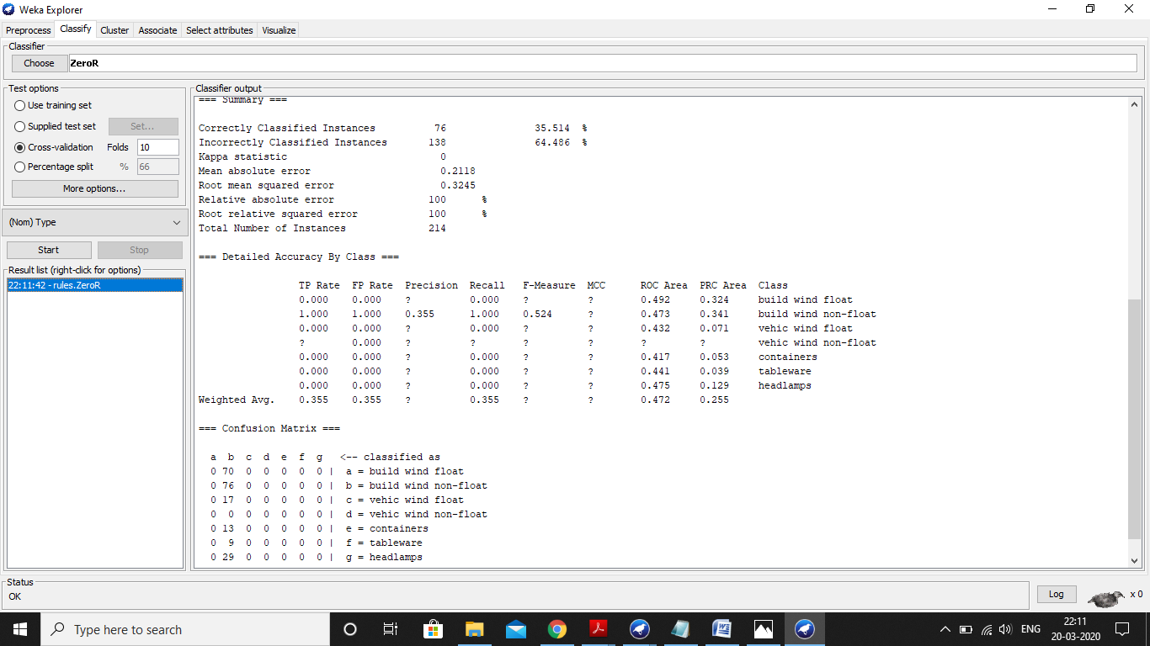

* + How many items are there in the dataset?
  + List the attributes are there in the dataset.
  + List the classes in the dataset along with the count of instances in the class.
  + How will you determine the color assigned to each class?
  + By examining the histogram, how will you determine which attributes should be the most important in classifying the types of glass?

1. Perform the following classification tasks:

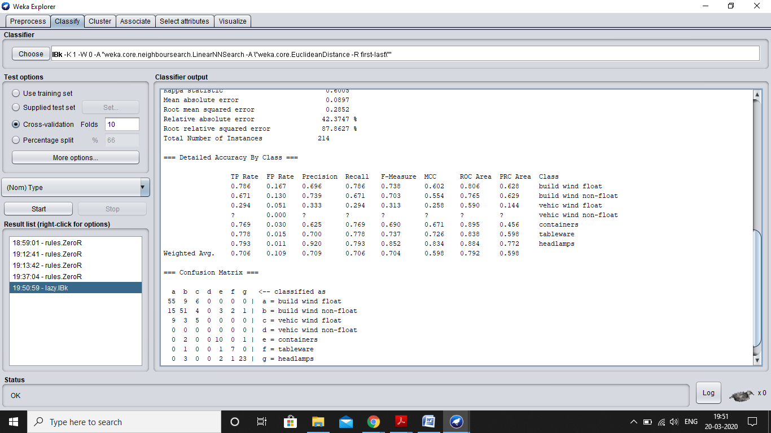

* + Run the 1Bk classifier for various values of K?
  + What is the accuracy of this classifier for each value of K?
  + What type of classifier is the 1Bk classifier?

1. Perform the following classification tasks:

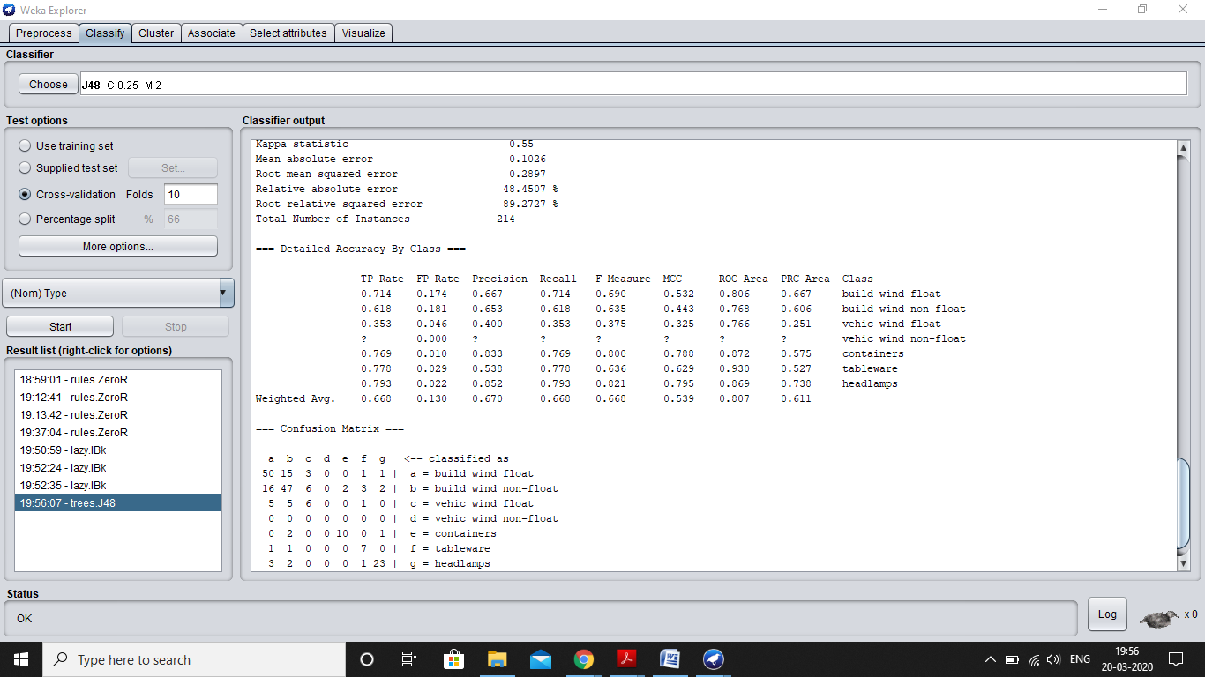

* + Run the J48 classifier
  + What is the accuracy of this classifier?
  + What type of classifier is the J48 classifier?

1. Compare the results of the 1Bk and the J48 classifiers. Which is better?
2. Run the J48 and 1Bk classifiers using

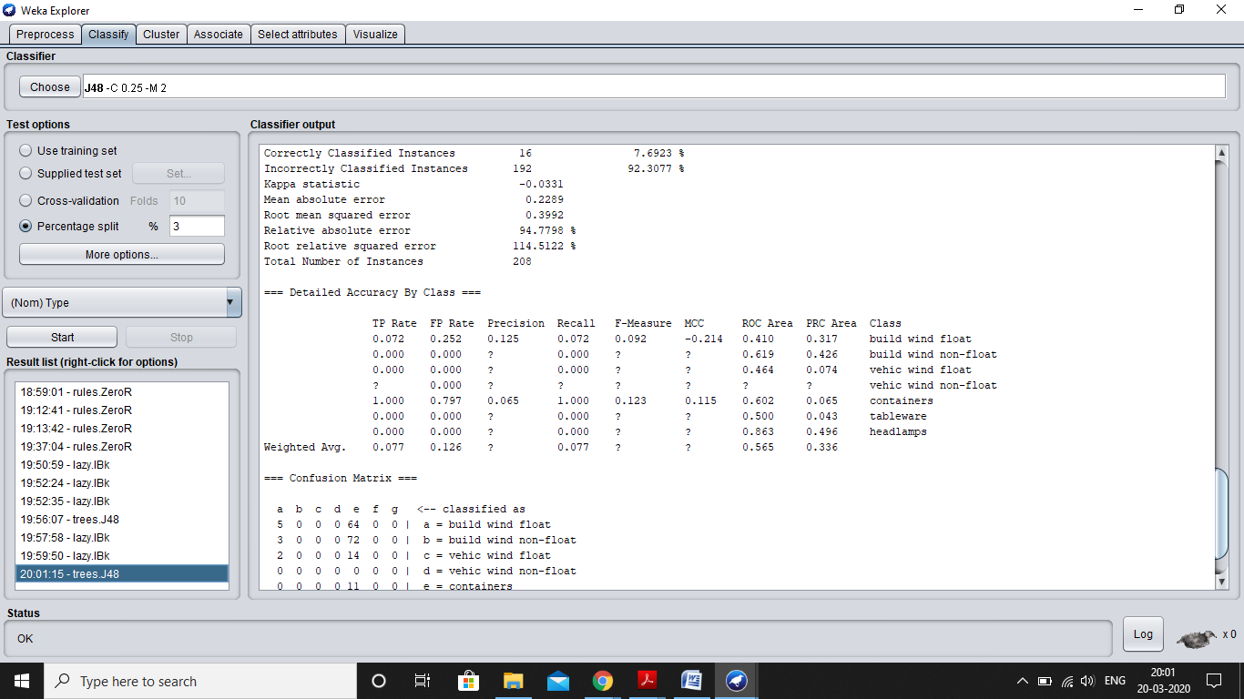

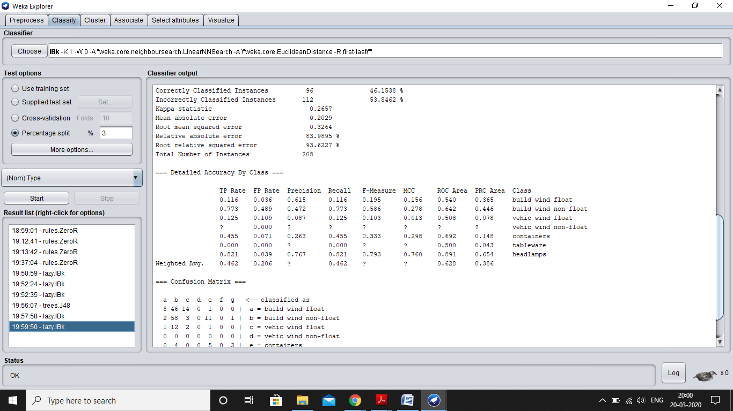

* + the cross-validation strategy with various fold levels. Compare the accuracy results. (Same as images in Q:5 and Q:6)
  + holdout strategy with three percentage levels. Compare the accuracy results.

1. Perform following tasks:
   1. Remove instances belonging to the following classes:

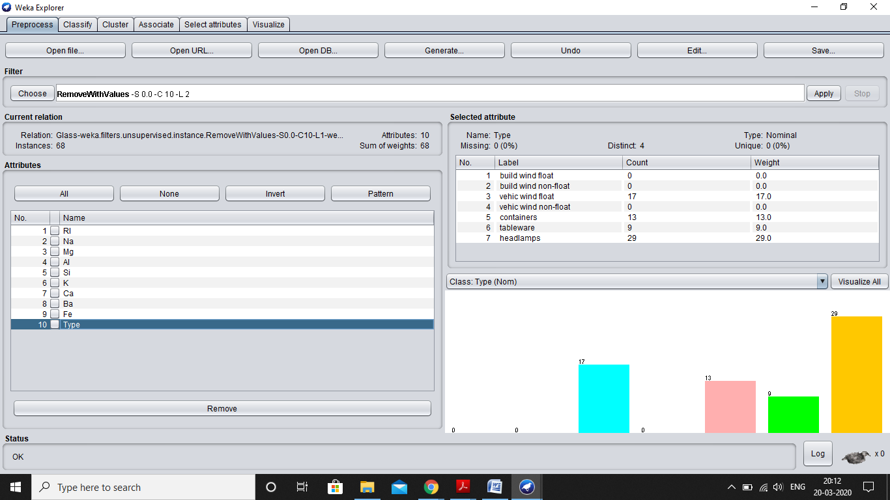

* + - build wind float
    - build wind non-float
  1. Perform classification using the 1Bk and J48 classifiers. What is the effect of this filter on the accuracy of the classifiers?

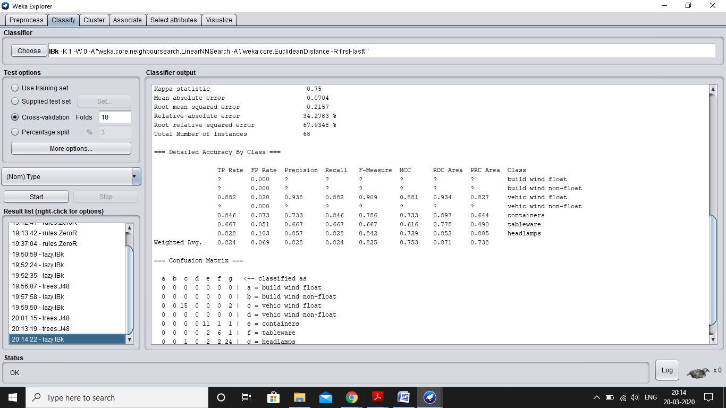

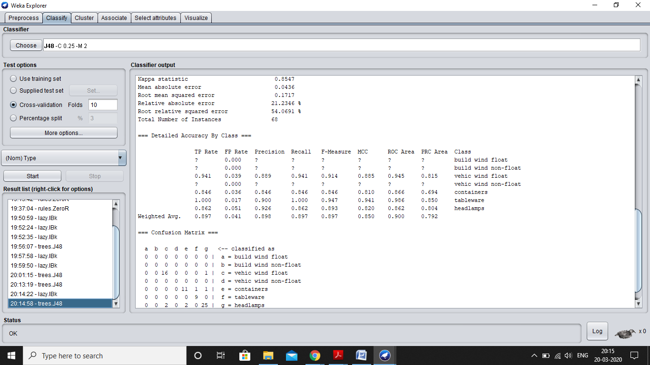

1. Perform the following tasks:
   1. Run the J48 and the NaiveBayes classifiers on the following datasets and determine the accuracy:
      1. vehicle.arff

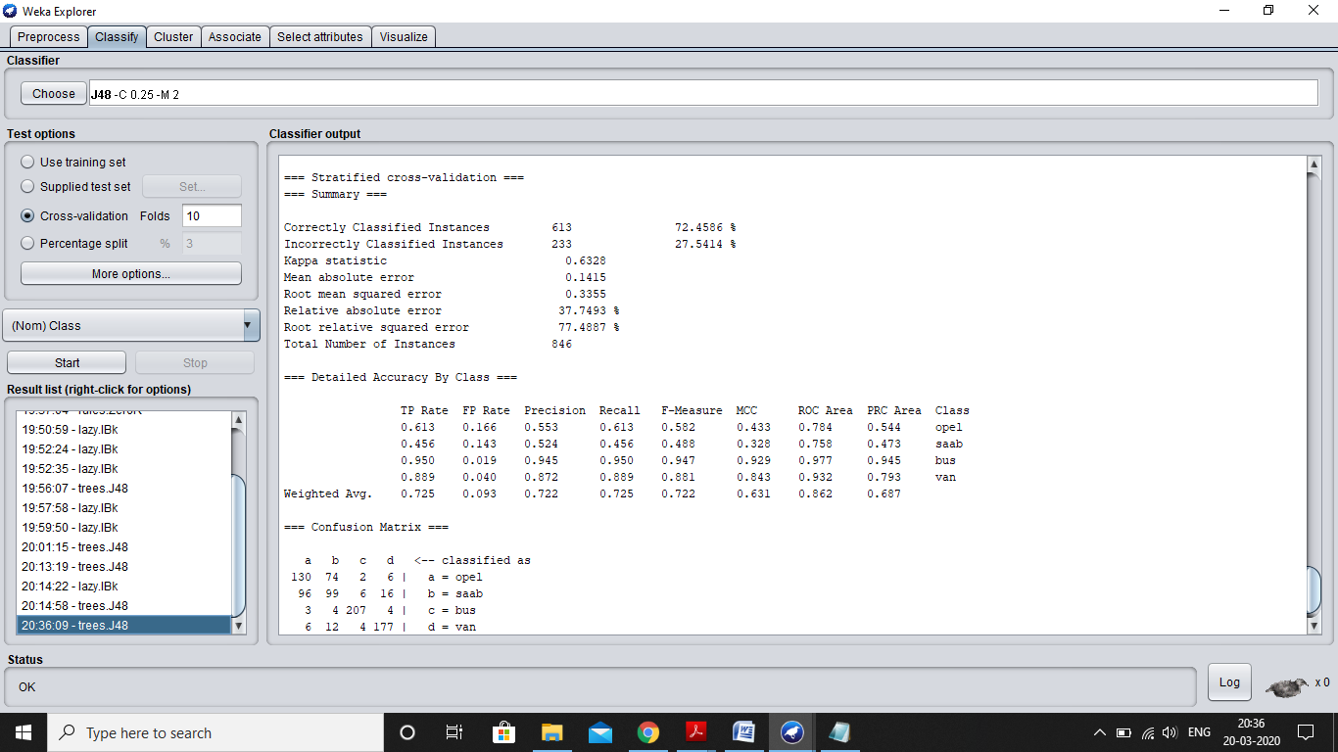

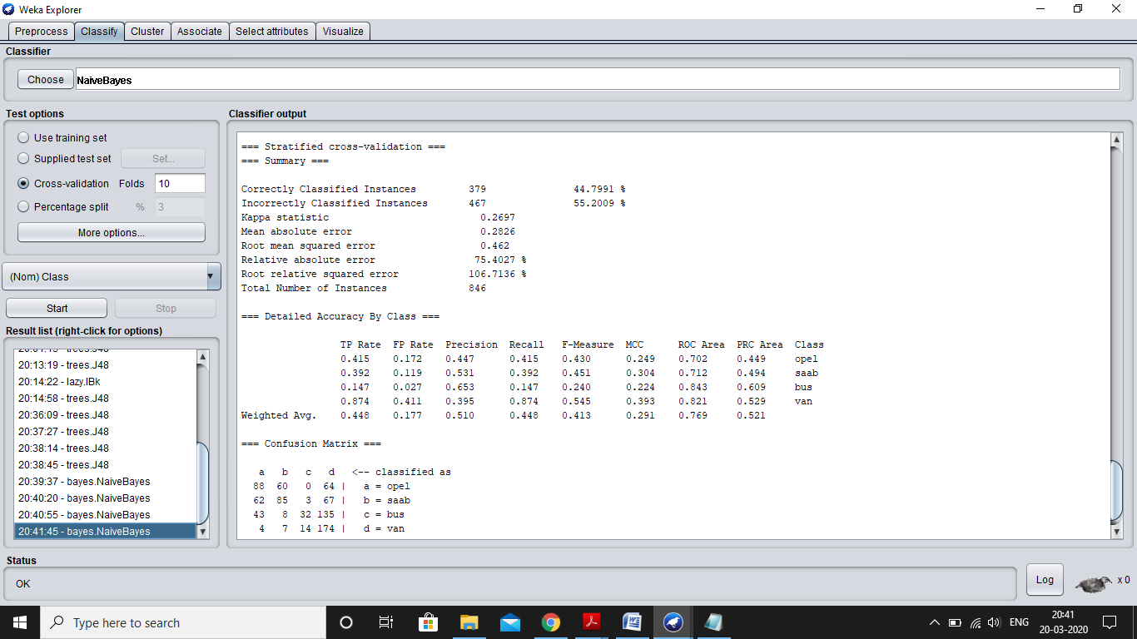

* + 1. kr-vs-kp.arff

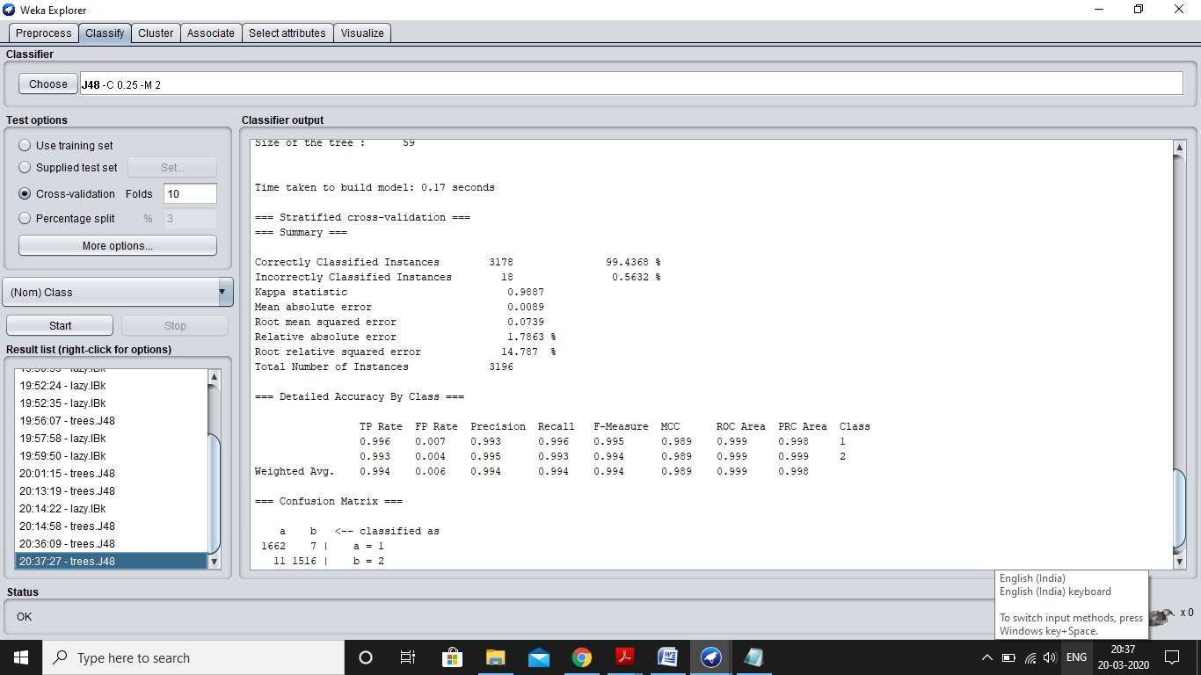

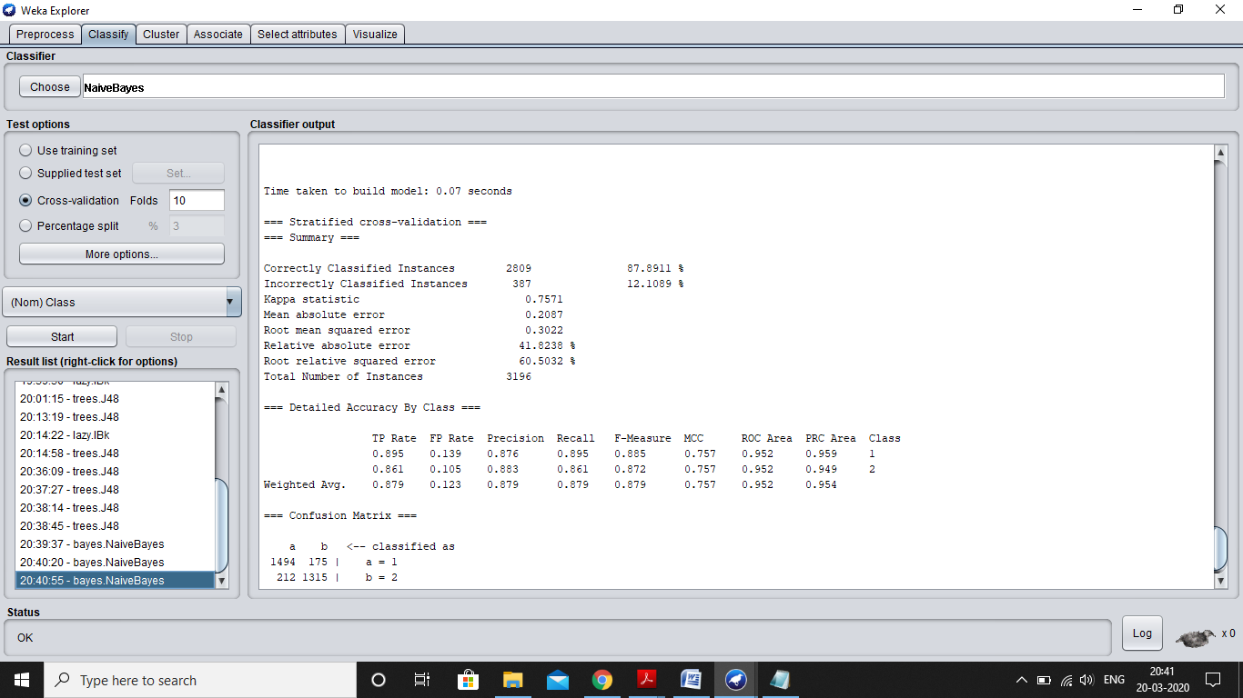

* + 1. glass.arff

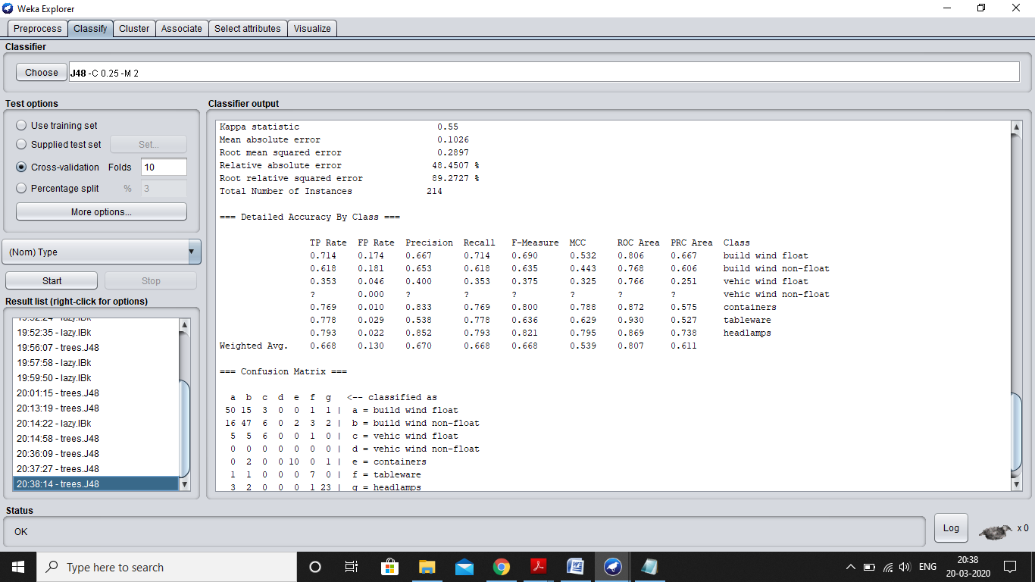

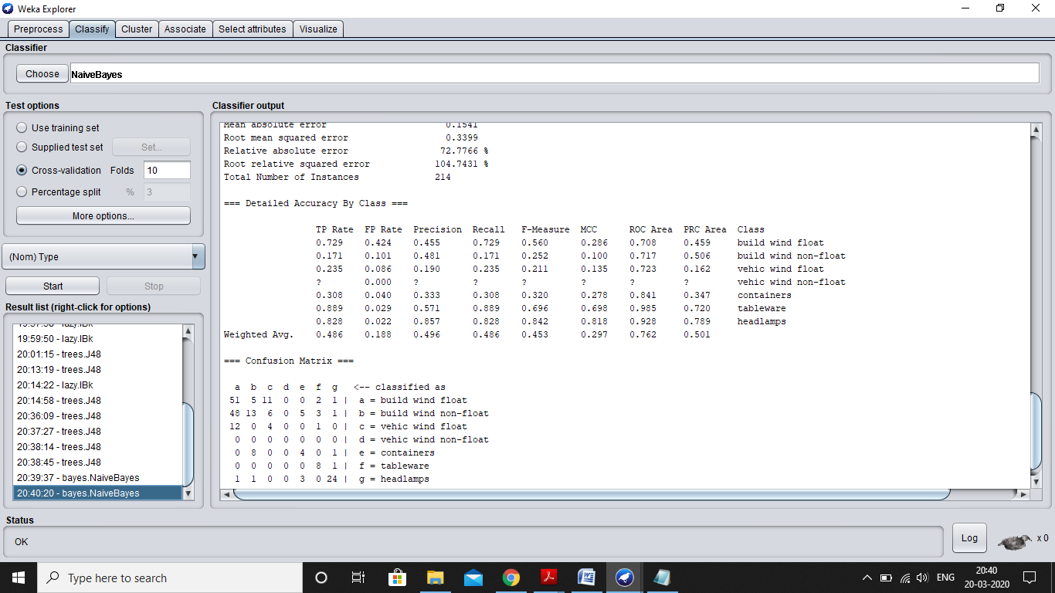

* + 1. wave-form-5000.arff

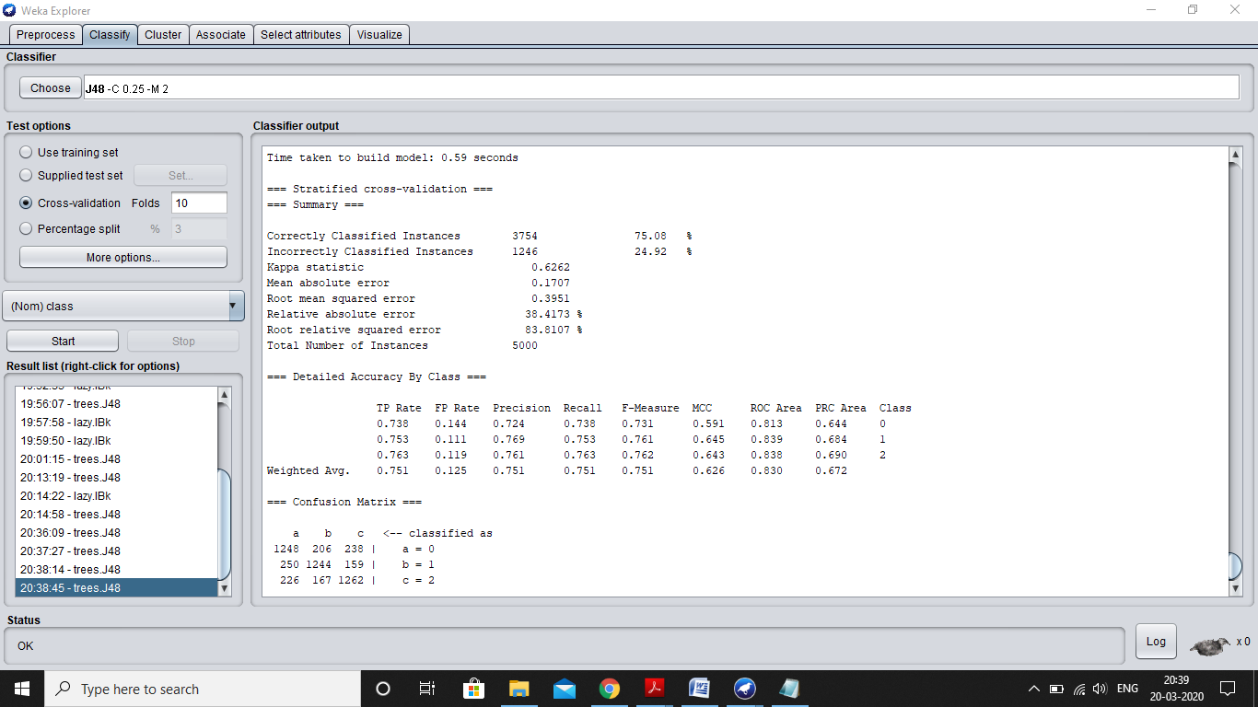

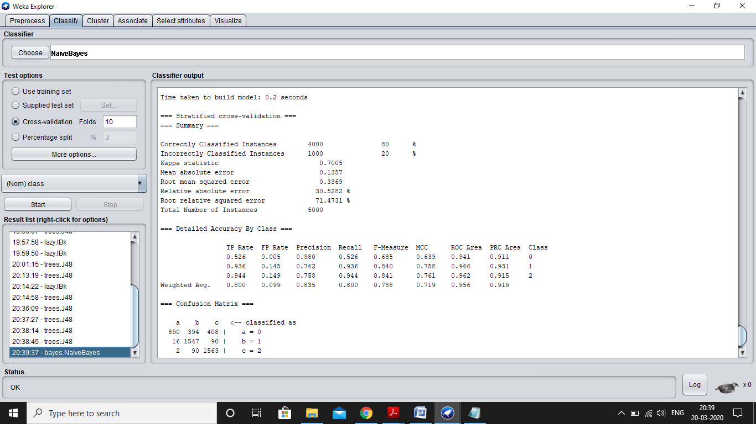

On which datasets does the NaiveBayes perform better? Why?

1. Perform the following tasks
   * Use the results of the J48 classifier to determine the most important attributes
   * Remove the least important attributes
   * Run the J48 and 1Bk classifiers and determine the effect of this change on the accuracy of these classifiers. What will you conclude from the results? (Same as images in Q:5 and Q:6)